“Hunger Is Scary” Neighborhood Volunteer Checklist
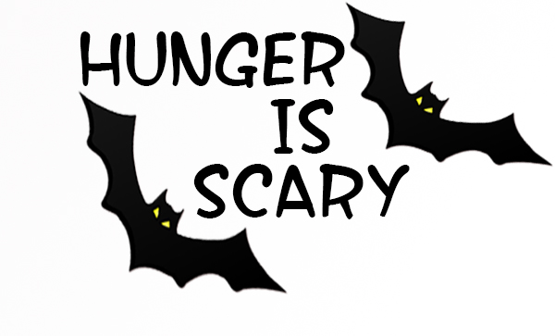
- By October 25th
  - Pick a neighborhood with a number of houses that you can easily cover. Don’t make it too hard on yourself! Cans are heavy…unless you will have a parent help carry or pick up as you go along.
  - Get permission from your parent to do participate in the collection. (Have them read this flyer).
- By October 29th
  - Place mailbox flyers in mailboxes for each house in your neighborhood(s) so your neighbors know you will be collecting donations for the food pantry and they can have the donation ready for you.
- On October 31st: Halloween Evening
  - Trick-or-treating:
    - Wear your “Hunger is Scary” Volunteer pin, and bring several bags with you.
    - Go house to house collecting the donated items –DO NOT GO ALONE!! You must have a friend or parent with you.
    - Ring the doorbell – announce that you are the “Hunger is Scary” representative
    - Collect the donated item, and give the donor a Thank You Card (please sign the cards ahead of time). Be very thankful for the donation…
    - Go trick-or-treating with younger siblings. They collect candy, you collect donated items.
    - HAVE FUN!!
  - Have a parent follow you, if possible, to help if donations get too heavy to carry.
  - Deliver the donated items to the designated drop-off location below on Halloween evening

DROP OFF LOCATION: _______________________________________ Contact: ______________________________
Have Fun and Be Careful While Collecting the Donations

