“Hunger Is Scary” Town Coordinator

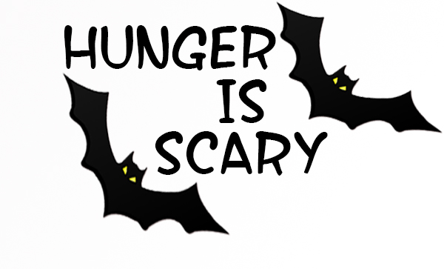
By October 15th
- Finds supermarkets, food pantries and other donors to support the food collection
- Find neighborhood volunteers
  - Get contact information (name, phone, e-mail)
  - Find out which neighborhoods and streets each volunteer is covering
  - Map out each volunteers route to make sure only one volunteer per neighborhood (use google to show streets)
  - Give all volunteers their bags, buttons, flyers and thank you cards
- Finds other ways to collect food during the Halloween season
- Locate a drop-off collection site for the volunteers to deliver the food
By October 25th
- Remind the neighborhood volunteers to deliver the flyers to each of the neighborhoods.
Halloween Evening - October 31st
- Be available for questions, or drop off of items collected by volunteers.
By November 5th
- Take an inventory of all of the collected food items.
- Send a note to tspushie3@gmail.com or call 201-563-9336 with a count by item, or weight of all donated items. (Usually the food shelter where you donate will weigh the food for you)
- Deliver the food to the local food pantry
- Send a personal thank you to all of the neighborhood volunteers

