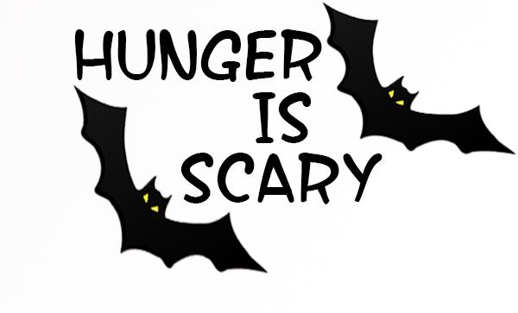
Halloween Food Drive
Collection Date: October _____
Pick-up between the hours of _______ and ________.

My Name is _______________________ and I am participating in this year’s Hunger Is Scary Halloween food drive.
The Center for Food Action is in desperate need of food this year. The shelves are empty due to low food and monetary donations during the ongoing COVID pandemic. If you would like to contribute, leave your item(s) in a bag on your front porch, and I will pick it up on the date & times listed above. THANK YOU!
All food donations will benefit the Center For Food Action
While any donation is greatly appreciated, please see below a list of suggested donation items (no glass jars, please) *Items are in high demand.
Canned Hearty Soup and Stews* | Cereal or Oatmeal
Pasta and Mac & Cheese | Peanut Butter and/or Jelly
Canned Fruits and Vegetables | Boxed Milk*
Canned Tuna | Healthy Snacks for Kids*
Canned Chili or Corn Beef Hash | Diapers (sizes 4/5/6)*
Tomato Sauce | Baby Food
Grocery Store Gift Cards* | Cash Donations* visit cfanj.org

Thank you for your generosity
*For more information on CFA and for cash donations visit www.cfanj.org.
*For more information on Hunger is Scary visit www.hungerisscary.com

