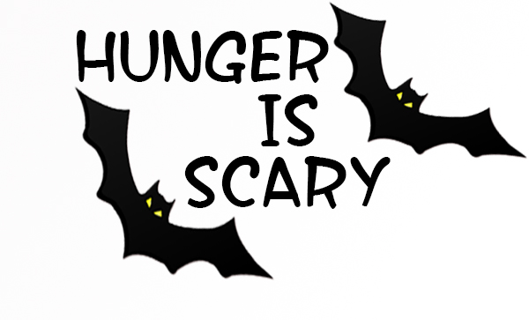
www.hungerisscary.com
This Halloween volunteers across Mahwah will be "trick-or-treating” to help the Center for Food Action (CFA) stack their shelves for those-in-need. They are trading in their “tricks or treats” for “cans and donations”! And you can help!
Your neighborhood volunteer will be ringing your doorbell on Halloween evening** to collect non-perishable food and other items that are most needed at this time of year (see the attached CFA flyer for suggested donations). It is up to all of us to make sure that our local families can put food on their tables for the holidays! Let’s do it together…
Your “Hunger is Scary” neighborhood volunteer is:

Name: ________________________ Address: _________________Mahwah, NJ

Imagine if every family in Mahwah donated just one dollar or one food item – the CFA shelves would be full! So please, have a can or other non-perishable item, or items, ready to hand to your volunteer and help eliminate hunger in our community for good!

“Trick or Treat, You’re so Sweet, Give Me Something Good to Eat”

More about the Center for Food Action:
The mission of the Center for Food Action is to “prevent hunger and homelessness and improve the lives of individuals and families living in poverty”. You can also visit the CFA website directly at www.cfanj.org to make a virtual food or financial donation. Your financial donation to the CFA will be put to work immediately to help local families and individuals who are struggling to keep food on their tables and a roof over their heads.

“Hunger Is Scary”:
For more information on the "Hunger is Scary" campaign, or to volunteer to host an event, please contact the Pushie Family at tspushie3@gmail.com or 201-316-0581. You can also visit the “Hunger is Scary” website at www.hungerisscary.com to learn more about the food campaign and become a donor or volunteer.

(** If you won’t be home during this time, please consider leaving your donation by your front door for your volunteer to pick up. Thank you)

